**Overview:**

**Notes on design:**

My goals in designing this embosser were as follow:

* The embosser should cost $150-200. My original inspiration for this project was that if you can buy or build a capable 3D printer for that price, you should be able to do the same with a braille embosser.
* The embosser should be open source.
* The embosser should be entirely 3D printed or made with off-the-shelf components.
* The embosser should be simple. There should be as few parts as possible and, except for the electronics, no complex mechanisms.
* The embosser should have an optional case to protect the user and the embosser.
* The embosser should be well documented. This includes a bill of materials, detailed instructions, code, wiring diagrams, and stl and CAD files for all printed parts.

If you go looking you will find several similar projects but I found them to be either insufficiently documented or very complex to build. The complexity is not in and of itself a bad thing and may result in a more robust embosser, but that comes with a higher barrier of entry for building an embosser or repairing it if it becomes damaged. I think the only way my embosser fails on this account is in the electronics, although anyone who knows how to solder should be able do the wiring themselves.

**Future Improvements:**

* Implement user feedback. Please let me know any problems or suggestions you have!
* Move the power and keyboard cables so that they do not interfere with opening the lid
* Write code to allow the embosser to accept braille ASCII files to print
* Provide additional keyboard controls
* Implement QWERTY keyboard compatibility
* Implement more auditory feedback from embosser
* Detect when paper reaches the print line
* Make 3D printable gears as an option
* Search for alternative electronics which are simpler and/or less expensive
* Design PCBs to reduce wiring complexity
* Design alternate print heads to make different size dots
* Test different linear actuators

**Printed Parts:**

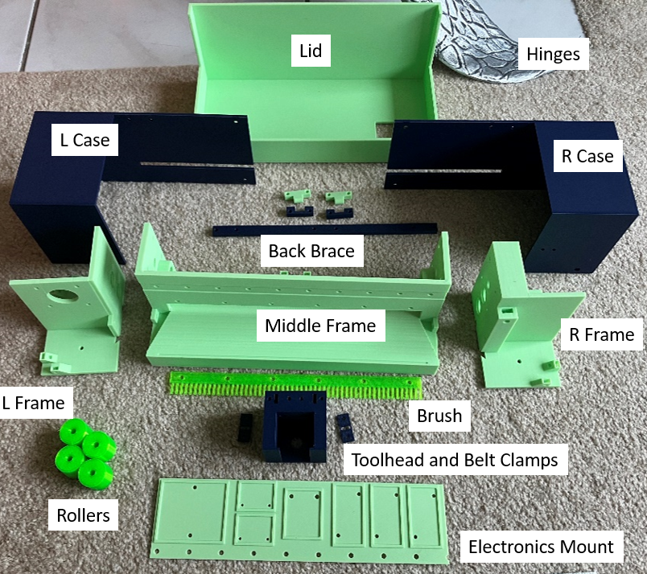

**Parts to print in TPU:**

* 4x **Rollers**: Cylinders 22mm in diameter and 20mm in length with a 5mm bore through the center. These are put on the linear rods and are used to grip the paper.
* 4x **Feet**: Conical pieces 10mm tall with 15mm and 10mm diameter ends a bore through the center for an M3 screw and nut. Used to reduce noise during printing and protect the surface the printer is on. Not present in the picture because I forgot to print them ahead of time.
* 1x **Lid Cable Protector**: Rectangular piece 55mm by 29mm with a 17.5mm by 7.5mm hole for the cable to the keyboard and a 13mm diameter hole for the power cable. Has a 4mm smaller rectangle on top of that which slots into the top of the lid so the cables isn’t damaged by the harder plastic of the lid.
* 1x **Keyboard Cable Protector**: Rectangular piece 25mm by 14mm with a 16mm by 4mm hole in the center. Has a 20mm by 5mm smaller rectangle on top which slots into the keyboard so that the cable running out of the keyboard isn’t damaged by the harder plastic of the keyboard case.

**Required parts printed in PLA/PETG:**

Note: I printed mine out of PLA because I have been actively redesigning parts and wanted to more easily reprint parts as I iterated. As is always the case with FDM printing, PLA will be less durable and UV sensitive so ideally the parts should be printed from a different material (in this case PETG is probably the most sensible choice). Note: the “ramps” that are described below exist to allow printing of M3 nut mounts without supports. They do not serve any other function in the printer.

* 1x **Left Frame**: Contains the x-motor mount as well as spaces for the left bearings. Rectangular base 65mm wide by 95mm long. On the base are 4 ramped structures 15mm wide by 7.5mm long by 7.5mm with space for M3 nuts. These are used for mounting the case to the frame. Rising from the base is a backwards L-shaped wall 87mm tall with one leg near the center of the base and the other on the far-right side extending to the back. Near the top, the front wall has four holes for M3 screw and a larger 25mm hole in the middle. These holes are used to mount the x-axis motor and allow the shaft the pass through to the front of the embosser. On the right side of the L-wall near the top are four holes for M3 screw for connecting the left frame to the middle frame. Below that are two sets of holes ~15mm in diameter for the bearings. These wholes have a larger, shallower hole around a slightly smaller deeper hole to accommodate the shape of the bearings. Just in front of the L-wall on the right side is a raised piece with an M3 screw hole on it as another point to attach to the middle frame. On the bottom of the left frame on the right side are two ~10mm dovetail cutouts that connect to the middle frame. On the bottom are also two M3 screw holes for mounting the TPU feet.
* 1x **Middle Frame**:
* 1x **Right Frame**: Contains space for the roller motor as well as spaces for the left bearings and a mount for the belt idler. Close to a mirror image of the left frame with the following differences: No holes for an x-axis motor, additional hole in the center of the four screw holes that connect to the middle frame to provide space for the roller motor shaft, spacer extending around those same four screw holes to provide space between the roller motor and the wall, the piece holding the front screw hole to connect to the middle piece extends upward about 60mm where it has an M5 screw hole and space for an M5 nut to mount the belt idler.
* 1x **Toolhead**: Attached to the linear rail on the middle frame. Holds the linear actuator and move in the x-axis of the embosser. ~50mmm cube with a large cutout in the front/middle for the linear actuator. At the back is a cutout to fit onto the carriage of the linear rail as well as a cutout for the belts to pass through. Four M3 screw/nut holes go through the toolhead vertically near the back to mount the belt clamps as well as rectangular holes for the belt to pass through.
* 2x **Belt Clamp**: Attached to the top of the toolhead to hold the belts in place. Rectangular pieces 25mm by 10mm by 2mm with two holes for M3 screws and a rectangular hole for the belt to go through.
* 1x **Electronics Mount**: Attached to the middle frame behind middle wall and used to hold electronic components in place. Rectangular piece about 230mm by 55mm by 1mm with a row of 9 holes for M3 mounting screws at the bottom. On the front are a series of raised outlines for the various electronic components with holes for M3 or M2 screw to hold each part in place. From left to right (the largest outline should be on the far left): Solderable prototype board above the first three mounting screw holes, two motor drivers both above the fourth mounting screw hole, ESP-32 S2 Mini microcontroller above the fifth and sixth mounting screw holes, LM2596 buck converters for converting the 12V input power to the 5V needed to power the microcontroller above the seventh set of screw holes. To the right of these is 65mm of empty space which could be used in the future for mounting additional components.
* 1x **Embosser**: A 10mm diameter base, 3.5mm top cone with a small raised dot on one the small end of the cone the size of a braille dot and the other end of the cone hollow. Friction fits onto the end of the linear actuator with the hollow end and is used to emboss the braille dots. Not pictured because I forgot to print it ahead of time.
* 1x **Keyboard Bottom**: An open topped box 167mm by 53mm by 20mm with six screw and nut holes for M3 screws to hold the electronics and **Keyboard Top** to the bottom of the keyboard. Has a 2mm cutout on the top for the **Keyboard Top** to snap into place. Has a 20mm by 6mm hole at the back for cables to pass through.
* 1x **Keyboard Top**: 163mm by 63mm by 9mm box with two cutouts for M3 screws to connect to the **Keyboard Bottom** and 10 slots for MX Cherry keyboard keycaps.

**Optional parts printed in PLA/PETG:**

* **Left Case**:
* **Right Case**: a mirror image of the left case.
* **Lid**:
* **Back Brace**:
* 2x **Hinge Outer**:
* 2x **Hinge Inner**:

**Purchased Components:**

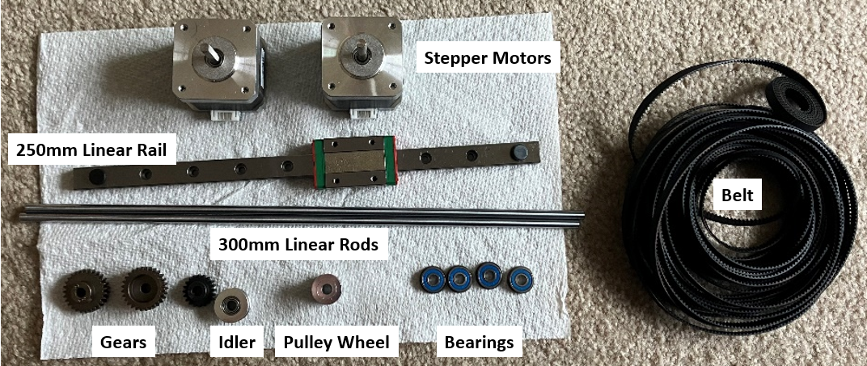

* 2x Stepper Motor: 42mm x 40mm stepper motors to drive the x-axis and rollers. Cube roughly 40mm/side. Near the bottom on one side face is a plug with six pins for plugging in a cable. On the top are four M3 screw holes for mounting the motor, a round 1mm by ~20mm raised ring with a 5mm shaft in the center. The shaft has one side flattened to allow a set screw to grip better.
* 1x 250mm Linear Rail: The toolhead will be mounted on the carriage of this linear rail to allow it to move on the x-axis. A metal rectangular piece 250mm by 5mm by 3mm with 10 holes for M3 mounting screws. On the a 40mm by 20mm rectangular carriage which slides along the rail. In the two outermost screw holes are rubber caps which prevent the carriage from sliding off and spilling the ball bearings inside it all over the place.
* 3x Gears: These gears come in two sizes. One is slightly smaller and will be attached to the roller motor shaft. The other two are slightly larger and will go on each of the two linear rods. The three gears will mesh in a vertical line in the order: Motor>Top Rod>Bottom Rod. Therefore, when the motor turns in one direction, the top rod will turn in the opposite direction and the bottom rod will turn in the same direction. For example: motor turning clockwise, top rod turning counterclockwise, bottom rod turning clockwise. Because the rollers on the top rod will be gripping the top of the paper and the bottom rod the bottom of the paper, the opposing directions of rotation will result in both rods pushing the paper in the same direction.
* 1x Idler: Placed on the opposite end of the linear rail from the x-axis motor and will allow the belt to loop back to the toolhead. A metal cylinder with a bearing in the middle and a 5mm bore. Around the outside of the cylinder are teeth to mesh with the belt.
* 1x Pulley Wheel: Attached to the x-axis motor to drive the belt. Metal cylinder with teeth on the outside to mesh with the belt. There are two holes 90° apart from one another on the rounded side for the threading of set screws to hold the pulley wheel on the motor shaft.
* 4x Bearings: Used to allow the rods to rotate freely while being held in place. Round metal pieces ~20mm in diameter with a 5mm bore. The center section can rotate freely.
* 1000mm (1m) Belt: Used to move the toolhead along the x-axis. 6mm wide plastic belt flat on one end and with teeth on the other. Embedded in the belt are strands of wire to provide added strength. Actual length used will be closer to 750mm.

**Fasteners**

|  |  |
| --- | --- |
| M2 Screws (M2x10 minimum, M2x20 maximum) | 6 |
| M2x10 Self-Tapping Screws | 2 |
| M2 Nuts | 6 |
| M3x8 Screws | 20 |
| M3x12 Screws | 19 |
| M3x18 Screws | 8 |
| M3x25 Screws | 1 |
| M3x30 Screw | 6 |
| M3 Nuts | 21 |
| M5x16 Screw | 1 |
| M5 Nut | 1 |

**Frame Assembly:**

In this section we will assemble the main frame of the embosser. As part of the that assembly we will also mount most of the components to the frame.

1. Insert bearings into the holes on the sides of the Left and Right Frames. The fit should be tight and the bearings should snap securely into place. The bearings should sit roughly flush with the wall of the once they are inserted.

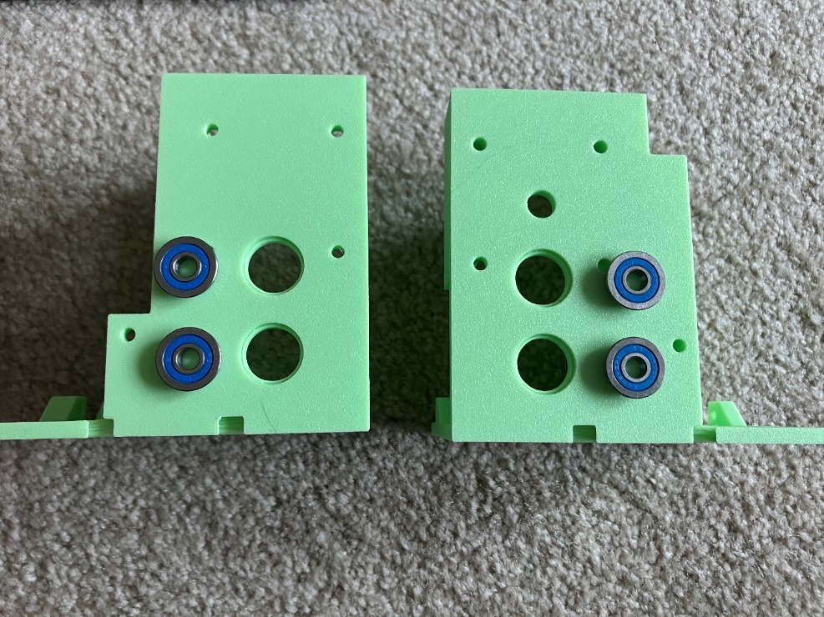

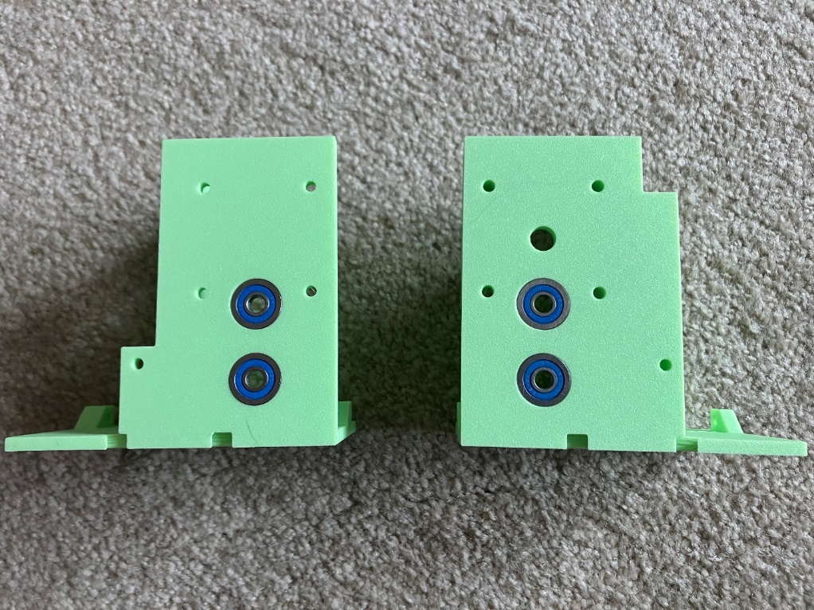

1. Connect the Left and Right Frames to the Middle Frame using the dovetails on the bottom. The wall running near the center of each of the frames should be colinear. If the walls are out of alignment you probably have the left and right segments swapped. The dovetails should be tight but can be removed if you made a mistake. The bottom of the frames do not need to be perfectly flush as connecting screw between the pieces will secure the frame.

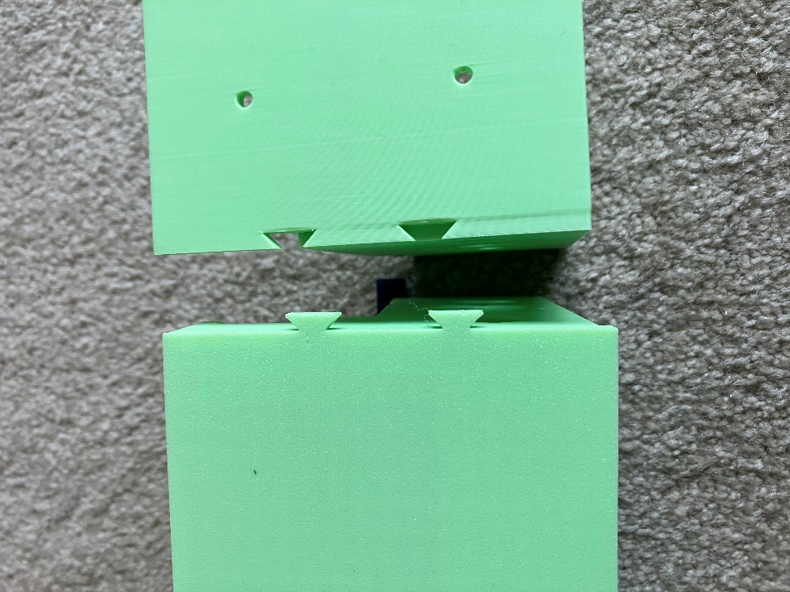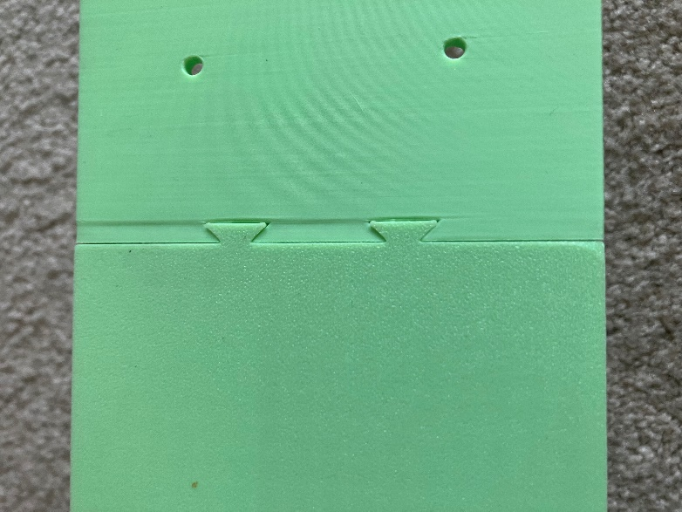

1. Attach the 3d printed feet to the bottom of the left and right frames with four M3x12 screws and four M3 nuts. There is space for a M3 nut to be trapped on the bottom side of the feet and a screw can be inserted from the top side of the frame.

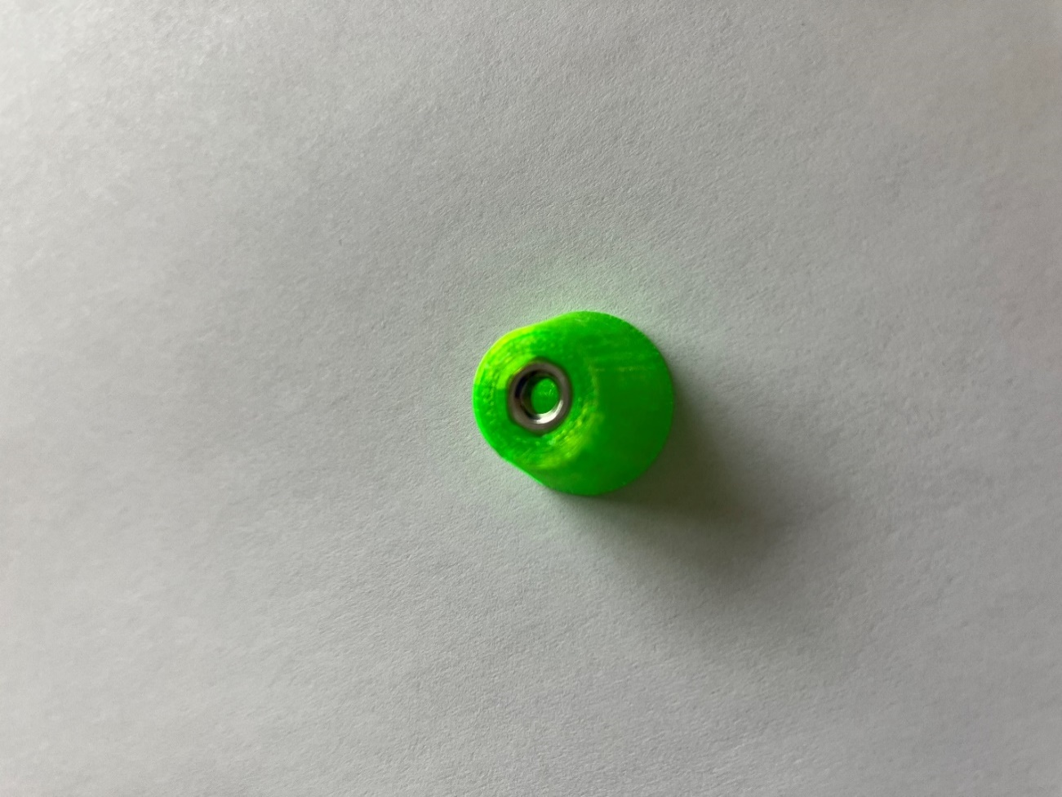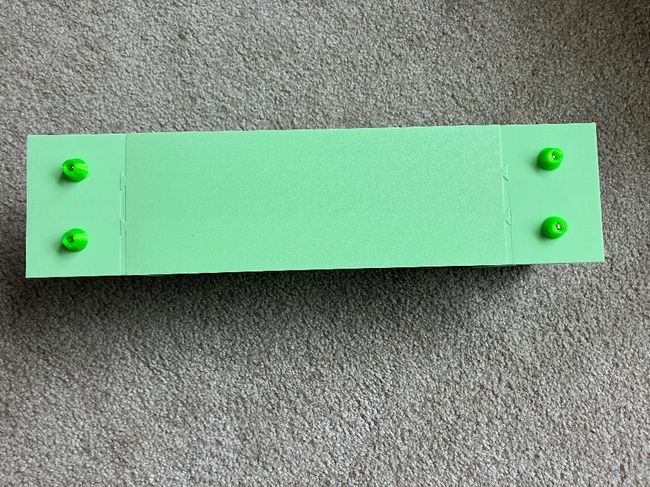

1. At the front of the frame, connect the Left Frame to the Middle Frame using the screw hole just in front of the middle wall using an M3x12 screw and an M3 nut.
2. At the front of the frame, connect the Right Frame to the Middle Frame using the screw hole just in front of the middle wall using an M3x25 screw and an M3 nut. Note: you can also use an M3x30 screw with an M3 nut put on by the head of the screw as a spacer. This reduces the number of different screws you need.
3. At the back of the frame, connect the Left Frame to the Middle Frame using the four screw holes on the parallel walls with four M3x12 screws and four M3 nuts

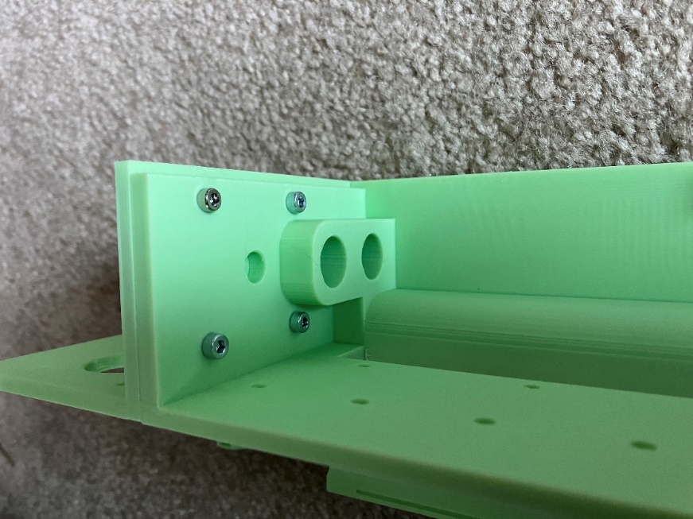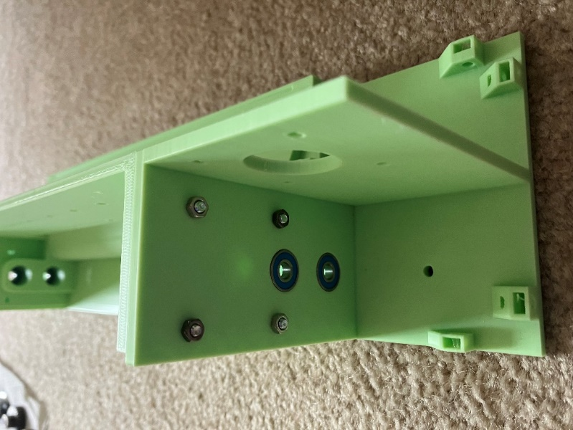

1. Attach the 32P 20T Mod 0.8, 5mm shaft Pinion Gear to one of the stepper motors by sliding it onto the shaft with the teeth farther from the motor body about 8mm from the end of the shaft. Align the set screw with the flat side of the shaft and tighten the screw. You should now be able to rotate the gear and shaft together without the pulley slipping. This will be the roller motor.
2. Orient the motor so the plug is oriented up. At the back of the frame, attach the roller motor to the top of the Right Frame (which will currently be on the left side of the frame since you are looking at it from the back) using four M3x30 screws. The screws will go into the four holes near the top on the left side (while looking at the frame from the back) of the Middle Frame, go through the thick wall on the Right Frame, and thread into the holes on the motor. Check to make sure the plug on the motor is still facing up. You may need to adjust the positioning of the pulley on the motor shaft. You can access the gear and its set screw from below. The gear should be close to the wall but ideally not touching the wall. The other gears will be larger so the exact placement of this gear is not critical to ensure that the gears mesh.

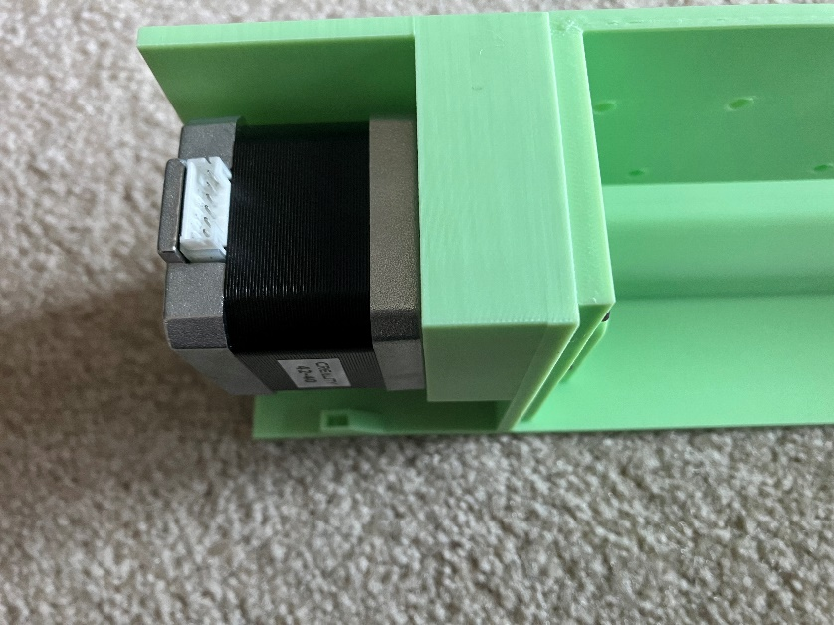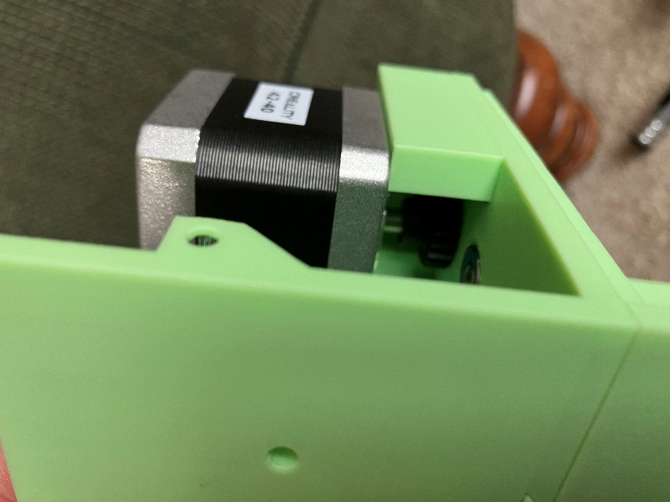

1. From the back of the frame, insert the linear rods through the bearing on the Left Frame (currently on the right side as we are viewing the back of the frame) and about halfway through the Middle Frame. Slide two roller grippers onto linear rods, ensuring that there is at least 20mm between the grippers and that there is at least 30mm of rod sticking past the leftmost gripper. Note: The grippers will be VERY tight on the rod. Starting with the top rod, slide the linear rods through the bearing on the Right Frame (currently on the left side as we are viewing the back of the frame) and put a 32P 27T Mod 0.8, 5mm shaft Pinion Gear on the left end of the rod flush against the Right Frame wall. Adjust the rod so the end is flush with the end of the gear then tighten the set screw on the gear. The top rod gear and the motor gear should mesh with a little bit of wiggle room. While holding the rod gear in place against the Right Frame wall, push the closes roller gripper toward the gear as far as it will go. Repeat with the farther gripper but moving it away from the gear to the far side of the Middle Frame. The top rod should now be able to rotate but not move from left to right. Attach the gear and adjust the roller grippers on the bottom rod in the same way you did for the top rod. The bottom rod gear should mesh with the gears on the top rod and when you turn one gear the other should move smoothly in the opposite direction. Try feeding some braille paper or an index card through the rollers by manually turning one of the rollers to ensure that both sets of rollers grip the paper. Note: regular printer paper will not work well as it is too thin and tends to crumple.

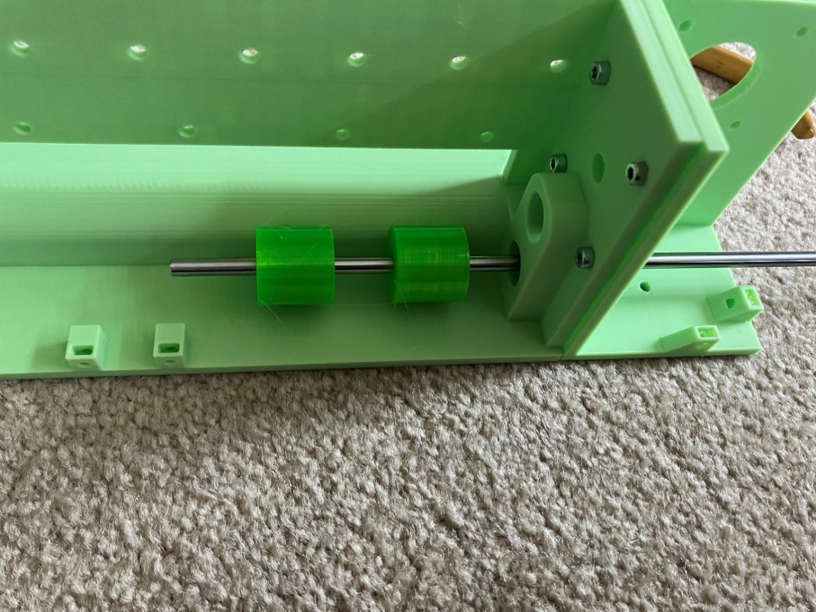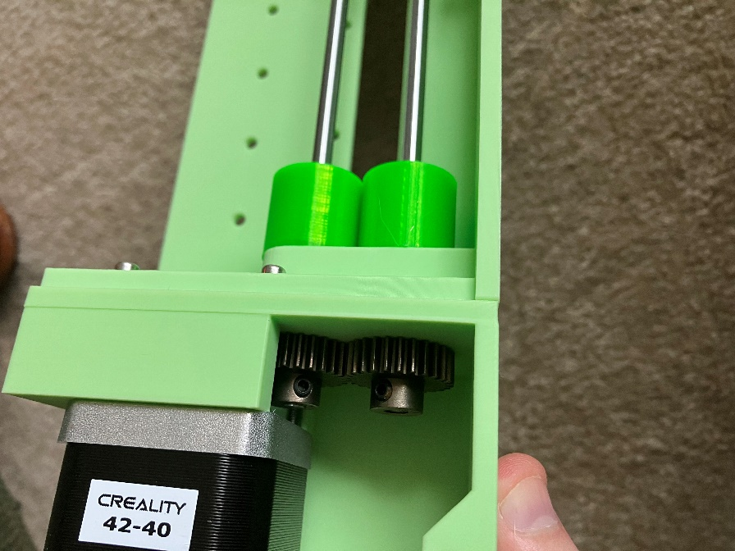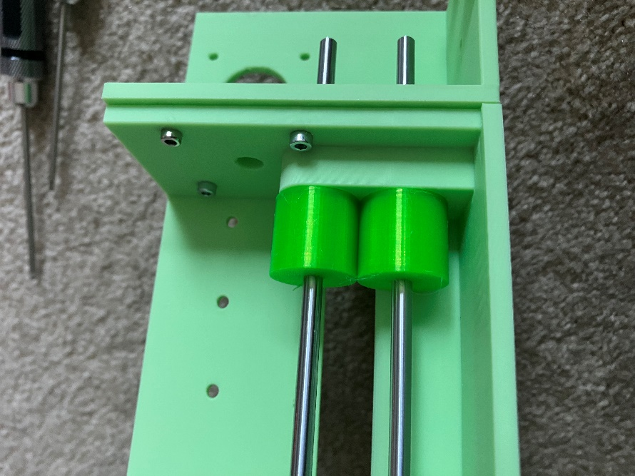

1. From the back of the left frame, put the second stepper motor (which will be the X motor) shaft through the large hole and screw it in place with four M3x8 screws. Put the pulley wheel on the shaft flush with the end of the shaft. Tighten the set screw against the flat edge of the shaft.

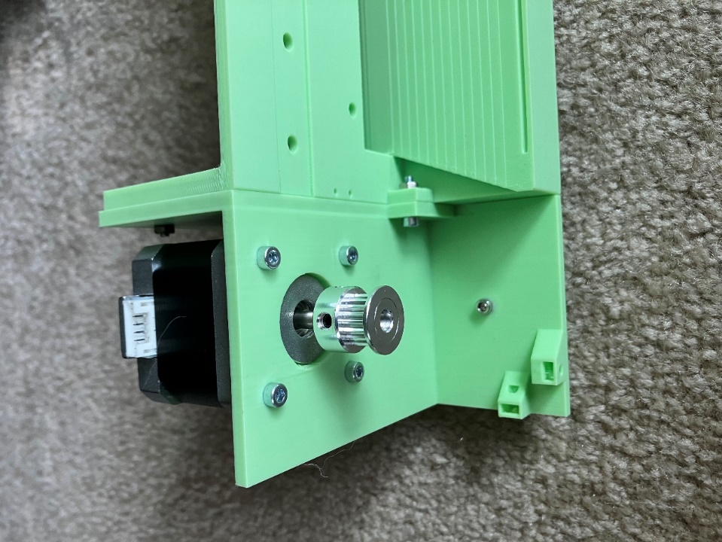

1. Attach the linear rail and brush to the front of the Middle Frame. Note: Do not take the rubber caps off the linear rail yet to prevent the carriage from sliding off. The linear rail goes in the inset channel near the top of the middle wall using between four and ten M3x16 screws and M3 nuts. Not every screw hole needs to be used although they can be; I found one on each end and two near the center seemed to work well. ~~The brush is attached below the linear rail with the “bristles” facing down using six M3x8 screws and M3 nuts.~~ I removed the brush as it caused problems. Pictures will continue to include the brush until I take new ones.

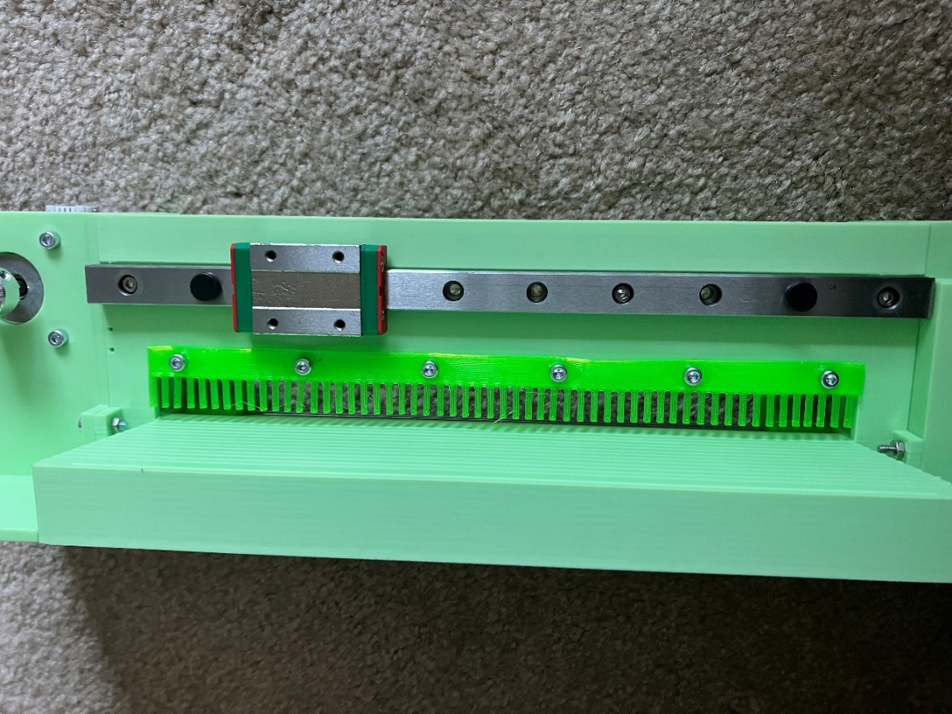

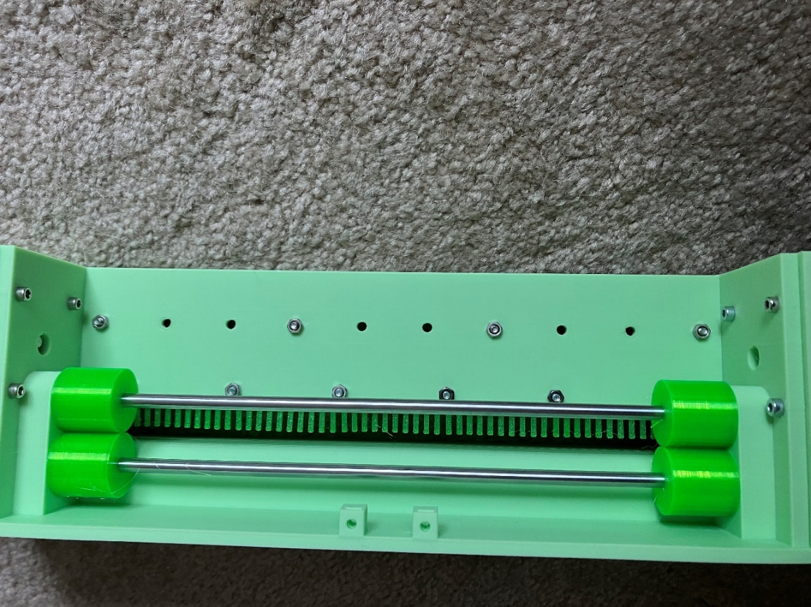

1. On the front of the Right Frame, insert an M5 nut into the hole at the top of the column just to the right of the linear rail. Put the idler onto an M5x16 screw and thread it through the hole into the nut. Adjust the tightness so the idler can just turn freely.

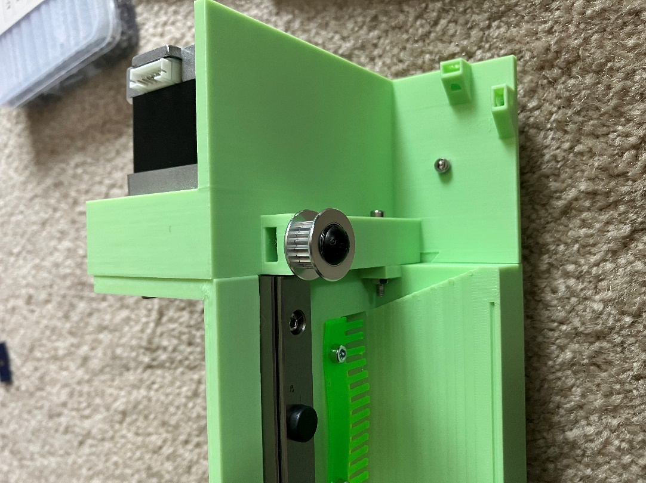

1. Screw the endstop into the two small holes to the left of the linear rail with M2x 10 self-tapping screws. The lever on the endstop should be facing upwards so that when the **Toolhead** moves to the left side of the rail it clicks the endstop. Once the end stop is mounted you can remove the rubber caps from the linear rail.
2. After mounting all the electronics on the **Electronics Mount**, secure the mount to the back middle of the printer using M3 nuts on the ends of the screws holding the linear rail. The electronics should facing the back of the printer and the **Electronics Mount** should be sticking up past the center wall.

**Toolhead Assembly:**

1. Insert an M3x16 or longer screw, through one the top holes in the **Toolhead**. Screw an M3 nut onto the end of it and tighten the nut. The nut will be pulled up into the hexagonal hole. Tighten the nut firmly to secure it in place then remove the screw. Repeat for the other three holes on the top of the **Toolhead**. The image below shows an example of a screw stuck through one of the holes with a nut on the end. Once the nut is tightened it will be pulled up until it is out of view and pulled tight against the plastic near the screw head.

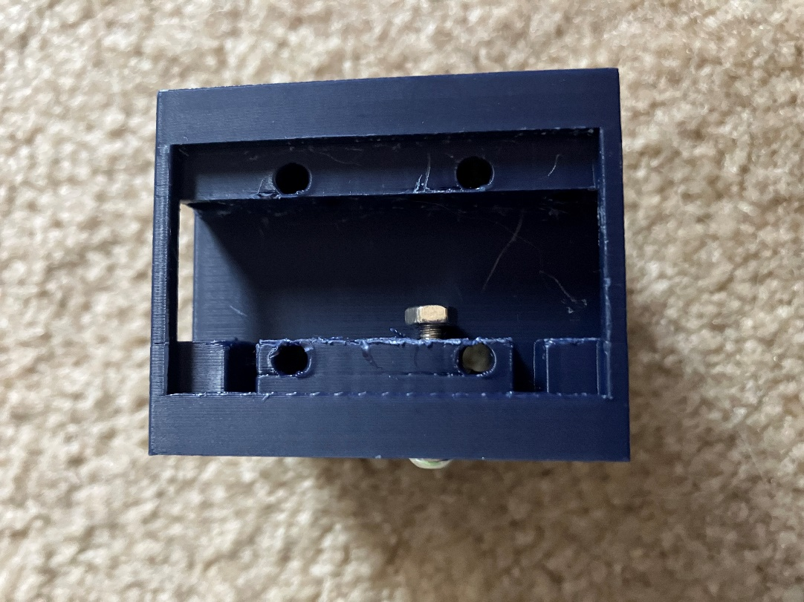

1. Loop the belt around the X-motor pulley with the teeth facing in. Hold one end of belt by the carriage (it doesn’t matter where on the linear rail the carriage is) and loop the other end idler and back to the carriage. The belt should now form a rough oval with the pulley on the left side, the idler on the right side, and both ends of the belt together at the top of the oval where the carriage is. Ensure you have ~30mm of extra length on each end of the belt and, if necessary, cut the belt to length. It’s better to have more than you need as you can always trim it later.

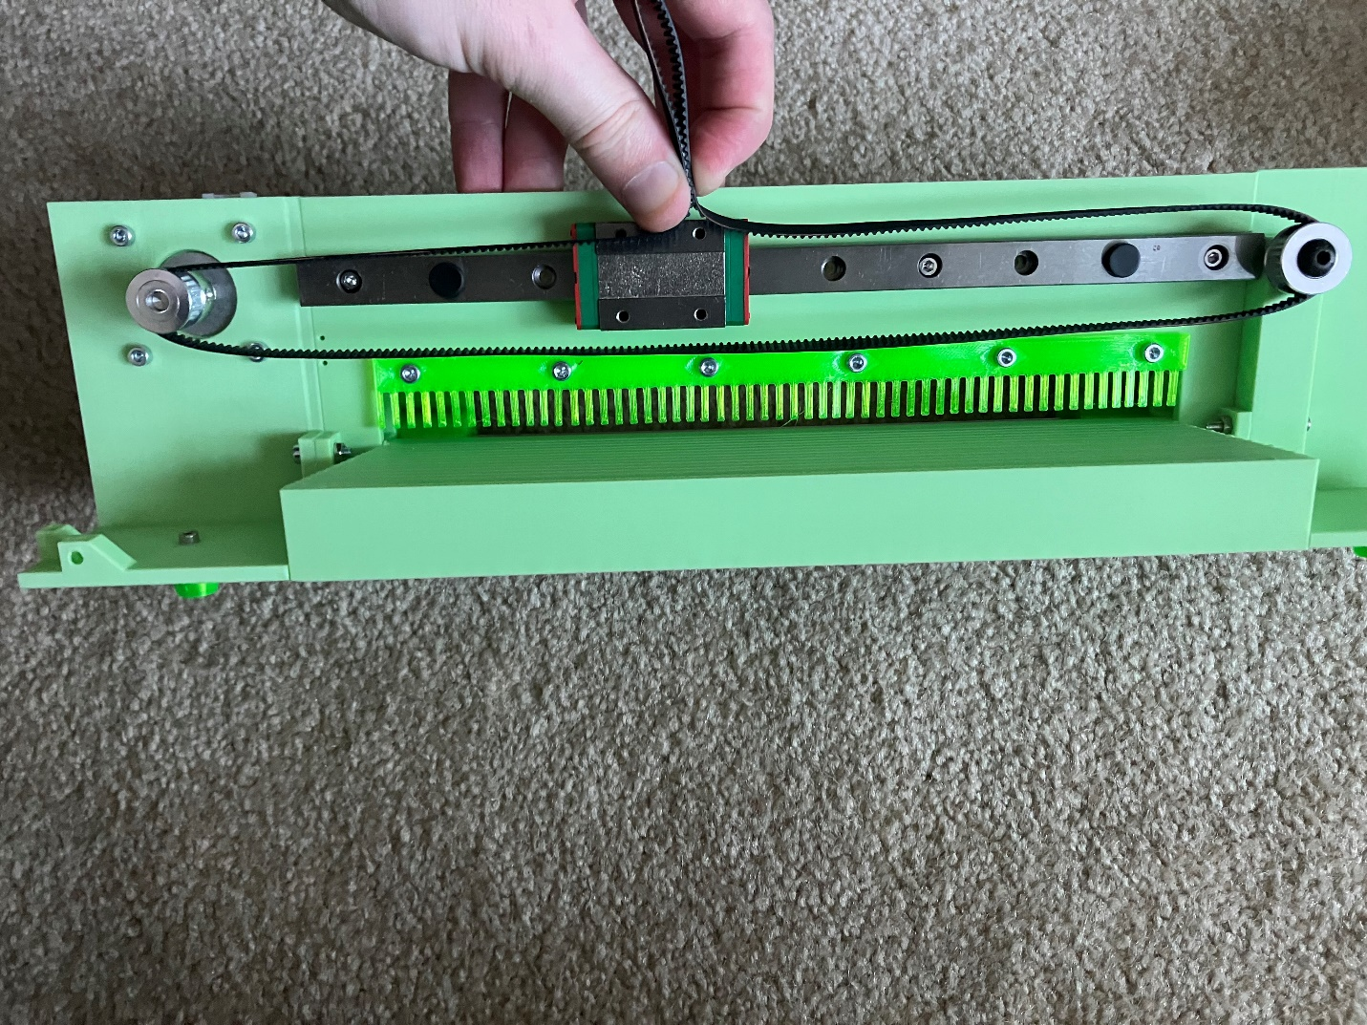

1. Remove the belt from the frame and run it through the back of the **Toolhead** in the same pattern. The teeth of the belt should always be facing the inside of the loop. Pass the two ends of the belt through the rectangular slots on the back of the **Toolhead** and out the top of the toolhead with about 20mm of length sticking out the top. The teeth on the belts should be facing toward each other and the center of the **Toolhead**. Slide a **Belt Clamp** onto each end and tighten them to the trapped nuts placed in step 1 using M3x8 screws. You do not need to completely tighten these screws right now, just enough to keep the belts from sliding back out.

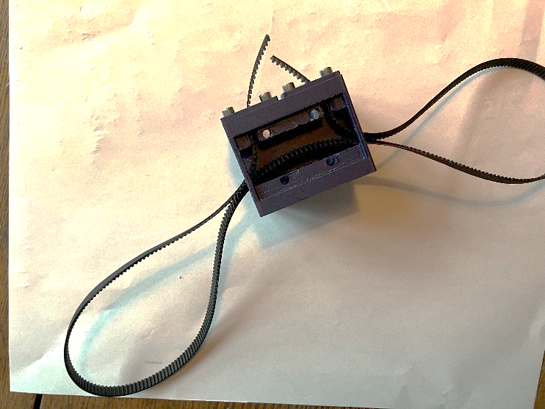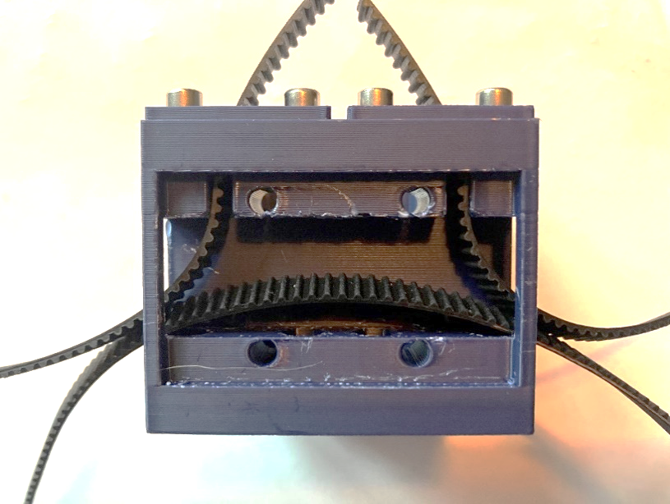

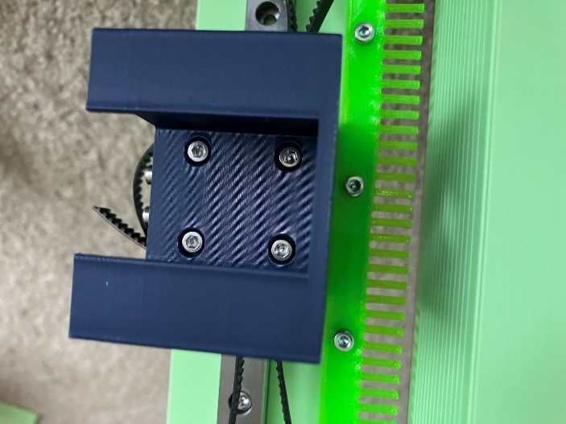

1. Screw the **Toolhead** with the round hole facing down onto the carriage with four M3x18 screws.
2. Loosen one of the two **Belt Clamps** (it doesn’t matter which one) and tighten the belt as tight as you can. While maintaining tension on the belt, tighten the **Belt Clamp** back down. The belt will still have some flex to it but should not be loose. If you pluck the belt, you will hear a soft twang. You should now be able to quickly and smoothly slide the toolhead from one end of the belt to the other without any slipping of the belt or binding of the carriage to the rail. The exact tension of the belt is not critical as long as the belt doesn’t slip.
3. Put the linear actuator into the **Toolhead** with the flat side of the plunger going through the hole in the bottom of the **Toolhead**. The actuator can be put in with the wires facing the back or the front and secured using the screw holes on the sides (there are holes on both sides but you will only use one set). Ideally the cable should be at the back of the toolhead so it is out of the way, but depending on how they coiled the wire there may not be space. Do not completely tighten the side screws as the position of the actuator will need to be adjusted later. SCREWS
4. Fit the **Embosser** onto the flat end of the linear actuator sticking below the toolhead. The fit will be very tight and the **Embosser** needs to be vertical. You can rotate the top of the linear actuator and feel the **Embosser** to see if the end of it is wobbling in a small circle. Adjust the positioning until the **Embosser** does not wobble.
5. Put a piece of paper under the **Embosser** and tap straight down on the linear actuator. Move the paper and repeat several times. If there is not a strong dot then loosen the screws holding the linear actuator in place and move it forward or backward as necessary. Repeat until you consistently produce dots that feel correct. With the screws at a particular tightness you should be able to slide the linear actuator with a little effort but have it stay in place otherwise, which makes this process easier. The tighter you can have the screws while testing the less chance that the alignment will change when you tighten them into their final position. Once you are finished tighten the screws and test the linear actuator again to make sure the alignment didn’t change when you tightened the screws. If necessary, repeat this process.

**Optional Case:**

The case is not necessary for the function of embosser, but will help keep dust and pets out and prevent possible injuries while the embosser is in use. It consists of 8 parts**: Left Case**, **Right Case**, **Lid**, **Back Brace**, 2x **Outer Hinge**, 2x **Inner Hinge**.

1. Assemble the hinges by placing an **Outer Hinge** and an Inner Hinge their curved faces toward one another. The hole in the **Inner Hinge** curve surface will align with the two on the Outer Hinge curved surfaces. Insert an M3x30 screw through both hinge parts (passing through the **Outer Hinge** twice and the **Inner Hinge** once) and tighten an M3 nut on the end. The tightness of the nut can be adjusted later to match how stiff you want the lid to be.

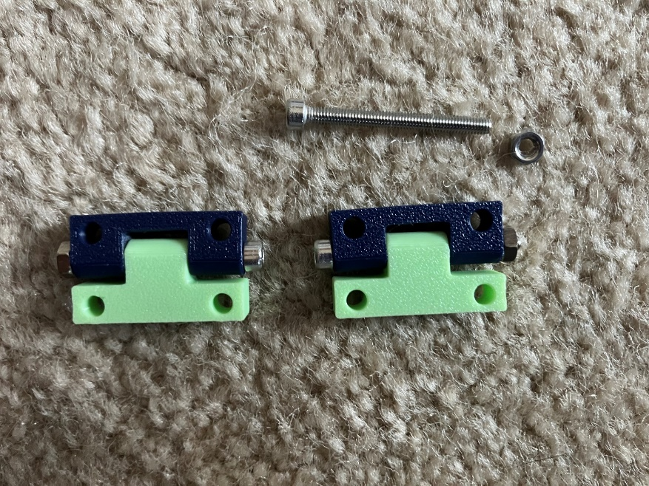

1. Align the **Left Case** and **Right Case** so that the long edges are colinear and the cutouts for the paper align with one another. The back wall of the case will have 6 screw holes (three on each half) in sets of two. These will align with the 6 holes on the **Back Brace**, which will go on the inside of the case. Attach the **Back Brace** to the **Left Case** and **Right Case** with two M3x10 screws and two M3 nuts in the center holes (one on each case segment). Using four M3x18 screws and four M3 nuts, attach **Outer Hinges** to the remaining four holes on the outside of the case with the **Inner Hinge** facing up. These screws will go through the **Outer Hinge**, the **Left/Right Case**, and the **Back Brace**, holding all three together.

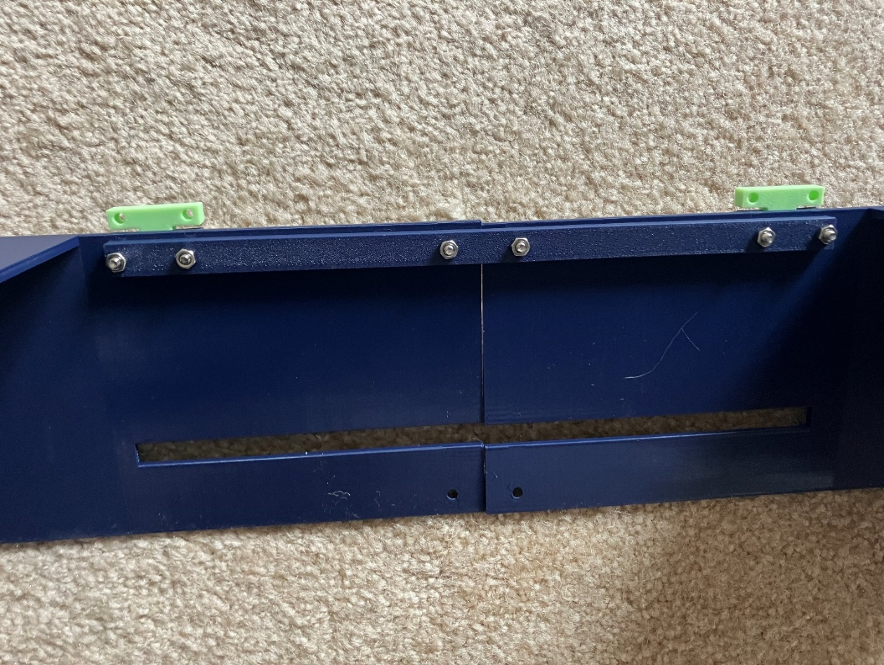

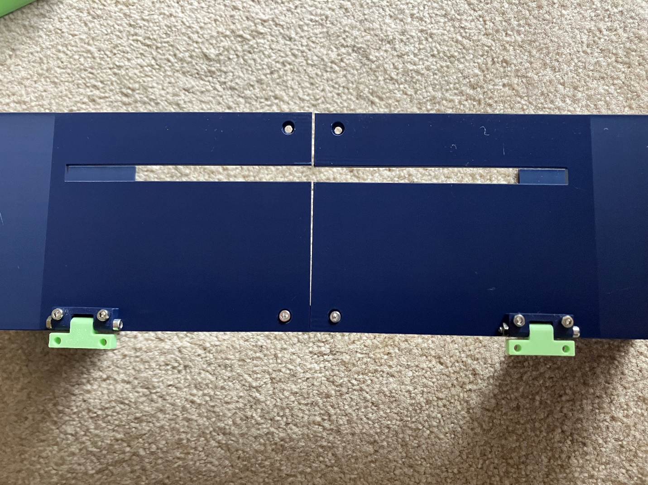

1. Attach the **Lid** to the **Inner Hinges** with four M3x12 screws and four M3 nuts. When the hinges are colinear, the lid should rest on the top surfaces of the case with the cutout on the top of the lid to the right.

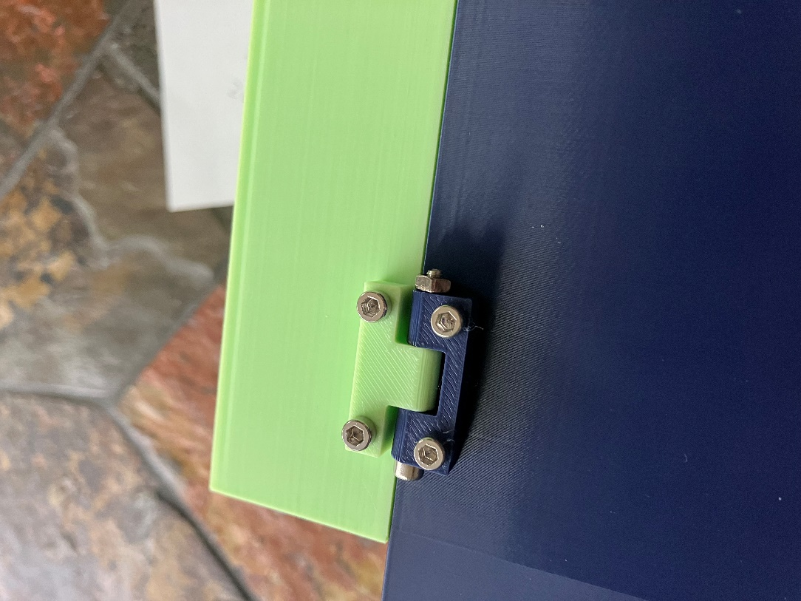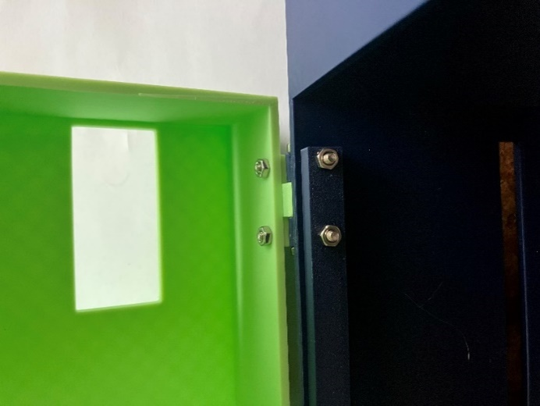

1. Insert 10 M3 nuts into the ramped holders on the outside edges of the frame. The nuts will not be completely tight in the slots, so don’t flip the embosser over until you’ve screwed on the case or else they’ll all fall out!
2. Set the case onto the frame and screw in 10 M3x6 or M3x8 screw into each of the holes, which will be secured by the nuts inserted in the previous step.
3. Fit the TPU **Lid Cable Protector** into the hole at the top of the lid.

**Keyboard Assembly**